Assignment no: 01

Code:

public class Car {

    String make;

    String model;

    short year;

    int price;

    public Car(String make, String model, short year, int price) {

        this.make = make;

        this.model = model;

        this.year = year;

        this.price = price;

    }

    public void displayInfo(){

        System.out.println("--Car detail--");

        System.out.println("Make: "+make);

        System.out.println("Model: "+model);

        System.out.println("Year: "+year);

        System.out.println("Price: "+price);

    }

    public static void main(String[] args) {

        Car c = new Car("India","maruti",(short) 2000,100000);

        c.displayInfo();

    }

}

Output:

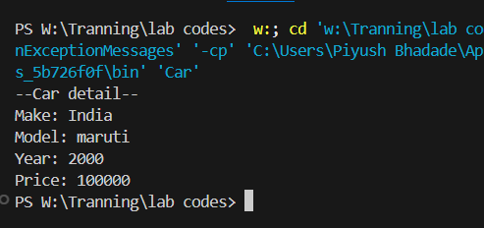

Assignment no: 02

Code:

public class calculator {

    int add(int a , int b){

        return a + b;

    }

    int add(int a , int b, int c){

        return a + b + c;

    }

    double add(double a , double b){

        return a + b;

    }

    public static void main(String[] args) {

        calculator c = new calculator();

        System.out.println("Addition of two numbers is: " + c.add(2,2));

        System.out.println("Addition of three numbers is: " + c.add(2,2,2));

        System.out.println("Addition two float number is: " + c.add(4.6,6.2));

    }

}

Output:

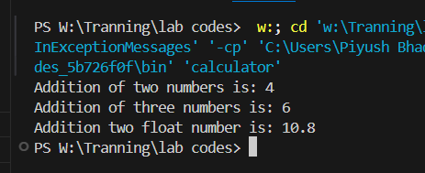

Assignment no: 03

Code:

Without main only getter and setter:

public class Studdent{

    private String name;

    private int age;

    private String department;

    public Studdent(String name, int age, String department) {

        this.name = name;

        this.age = age;

        this.department = department;

    }

    public String getName() {

        return name;

    }

    public void setName(String name) {

        this.name = name;

    }

    public int getAge() {

        return age;

    }

    public void setAge(int age) {

        this.age = age;

    }

    public String getDepartment() {

        return department;

    }

    public void setDepartment(String department) {

        this.department = department;

    }

}

With main method for sample example:

public class Studdent {

    private String name;

    private int age;

    private String department;

    public Studdent(String name, int age, String department) {

        this.name = name;

        this.age = age;

        this.department = department;

    }

    public String getName() {

        return name;

    }

    public void setName(String name) {

        this.name = name;

    }

    public int getAge() {

        return age;

    }

    public void setAge(int age) {

        this.age = age;

    }

    public String getDepartment() {

        return department;

    }

    public void setDepartment(String department) {

        this.department = department;

    }

    public static void main(String[] args) {

        Studdent s1 = new Studdent("Piyush",19, "Computer Engineering");

        System.out.println("Name: " + s1.getName());

        System.out.println("Age: " + s1.getAge());

        System.out.println("Department: " + s1.getDepartment());

    }

}

Output:

